**Recommendation Systems: Unleashing Personalization**

**Abstract:**

Recommendation systems play a pivotal role in various domains, aiding users in decision-making processes by suggesting items or content based on their preferences and past interactions. In this paper, we delve into the implementation of a recommendation system using methods such as correlation, weighted average, nearest neighbor, and cosine-sine similarity. Leveraging the IMDb dataset, we showcase the effectiveness and applicability of these techniques in generating personalized recommendations. We aim to provide a comprehensive understanding of recommendation systems, their significance in daily life, and detailed explanations of each method for both technical and non-technical audiences.

**Introduction:**

With the exponential growth of digital content and products, users often face a dilemma in choosing items that align with their interests and preferences. Recommendation systems address this challenge by analyzing user behavior and providing personalized suggestions. From e-commerce platforms recommending products to streaming services suggesting movies or shows, recommendation systems have become ubiquitous in daily life. In this paper, we explore the implementation of recommendation systems using various methodologies and evaluate their efficacy using the IMDb dataset.

**Methodology:**

1. Correlation Method: This approach calculates the correlation between items based on user ratings. By identifying items that exhibit similar user preferences, recommendations are generated for users. We elaborate on how correlation matrices are constructed and utilized in recommending items.

2. Weighted Average Method: Utilizing the IMDb dataset, we employ the weighted average technique to calculate item ratings based on user reviews. This method assigns different weights to ratings based on their relevance and significance, providing more accurate recommendations.

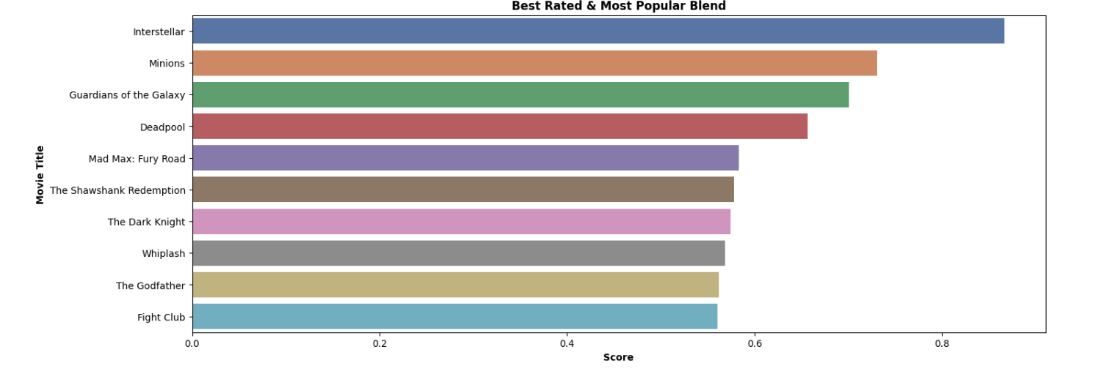

3. Nearest Neighbor Method: The nearest neighbor algorithm identifies users with similar preferences and recommends items based on their choices. We discuss how cosine-sine similarity measures are used to quantify the similarity between users and items, facilitating recommendation generation.

4. Cosine-Sine Method: This method calculates the cosine-sine similarity between items, considering their features or attributes. By comparing the characteristics of items, recommendations are generated for users, ensuring relevance and personalization.

**Implementation:**

In our implementation, we utilize the IMDb dataset, which contains a vast collection of movies and user ratings. We preprocess the dataset to extract relevant features such as movie titles, genres, and user ratings. Subsequently, we apply each of the aforementioned methods to generate recommendations for users based on their preferences and historical interactions.

**Literature Review:**

Various studies have explored recommendation systems using diverse methodologies such as collaborative filtering, content-based filtering, and hybrid approaches. While collaborative filtering relies on user-item interactions, content-based filtering analyzes item attributes. Hybrid approaches combine these techniques to enhance recommendation accuracy and coverage. Our paper focuses on methods like correlation, weighted average, nearest neighbor, and cosine-sine similarity, providing insights into their implementation and effectiveness.

**Results:**

Through our experiments, we demonstrate the efficacy of the implemented recommendation system using the IMDb dataset. Evaluation metrics such as precision, recall, and accuracy are utilized to assess the performance of each method. We present comparative analyses of recommendation quality and computational efficiency, showcasing the strengths and limitations of different techniques.



**Conclusion:**

In conclusion, recommendation systems are indispensable tools in today's digital landscape, facilitating personalized experiences for users across various platforms. By leveraging methodologies such as correlation, weighted average, nearest neighbor, and cosine-sine similarity, we can generate accurate and relevant recommendations. Through this paper, we have elucidated the significance of recommendation systems in daily life and provided detailed explanations of each method, catering to both technical and non-technical audiences. With further advancements in machine learning and data analytics, recommendation systems are poised to play an even greater role in enhancing user experiences and driving engagement.